NST21022 - Practical for Network Switching and Routing
Department of Information and Communication Technology
Faculty of Technology
Lab sheet :11
Reg. Number: SEU/IS/20/ICT/084
Academic Year :2020/2021
Practical No :11

Title: Introduction to VLANs
Aim:
• Getting familiar with VLANs and SSH

Task:
• Configure Basic Configuration
• Configure VLANs
• Configure Trunks
• Configure Secure Password and SSH

Use “NST21022 Labsheet 11.pka” file

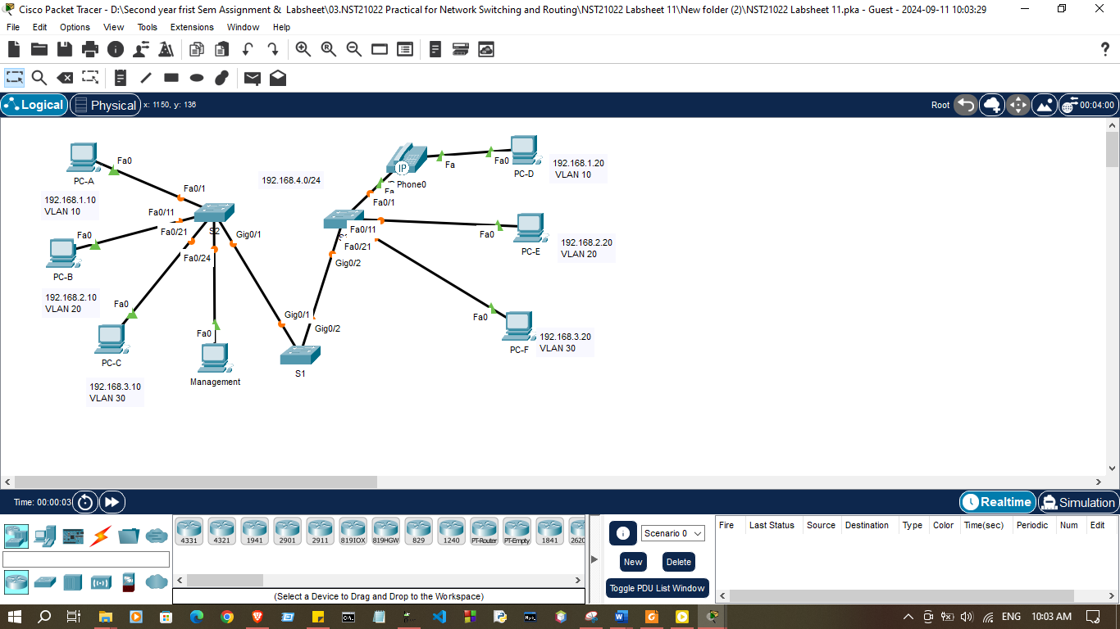

Activities

Addressing Table
Device | Interface | IP Address | Subnet Mask | VLAN
PC-A | NIC | 192.168.1.10 | 255.255.255.0 | 10
PC-B | NIC | 192.168.2.10 | 255.255.255.0 | 20
PC-C | NIC | 192.168.3.10 | 255.255.255.0 | 30
PC-D | NIC | 192.168.1.20 | 255.255.255.0 | 10
PC-E | NIC | 192.168.2.20 | 255.255.255.0 | 20
PC-F | NIC | 192.168.3.20 | 255.255.255.0 | 30
Management | NIC | 192.168.4.20 | 255.255.255.0 | 99
S1 | VLAN 99 | 192.168.4.11 | 255.255.255.0
S2 | VLAN 99 | 192.168.4.10 | 255.255.255.0
S3 | VLAN 99 | 192.168.4.12 | 255.255.255.0

Exercise 01: Configure Basic Configuration

- Configure the hostname for all Switches according to Addressing Table

Switch>enable
Switch#configure terminal
Enter configuration commands, one per line. End with CNTL/Z.
Switch(config)#hostname S1
S1(config)#

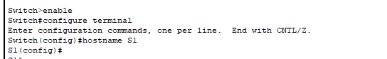

Switch>enable
Switch#configure terminal
Enter configuration commands, one per line. End with CNTL/Z.
Switch(config)#hostname S2
S2(config)#
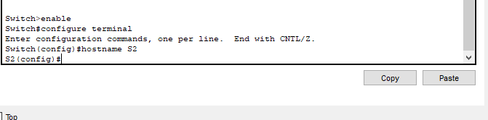

Switch>enable
Switch#configure terminal
Enter configuration commands, one per line. End with CNTL/Z.
Switch(config)#hostname S3
S3(config)#
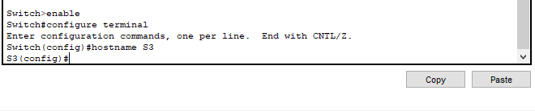

2. Set the domain name to ccna.com for all switches
S1(config)# ip domain-name ccna.com

S1(config)#ip domain-name ccna.com
S1(config)#
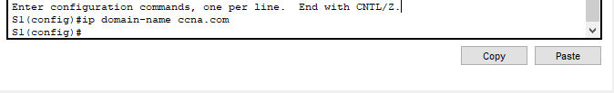

S2(config)#ip domain-name ccna.com
S2(config)#

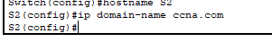

S3(config)#ip domain-name ccna.com
S3(config)#

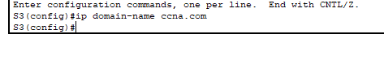

Exercise 02: VLAN Configuration
01.On S1 issue the command that displays all VLANs configured. By default, all interfaces are assigned to VLAN1

S1>show vlan brief

VLAN Name Status Ports
---- -------------------------------- --------- -------------------------------
1 default active Fa0/1, Fa0/2, Fa0/3, Fa0/4
Fa0/5, Fa0/6, Fa0/7, Fa0/8
Fa0/9, Fa0/10, Fa0/11, Fa0/12
Fa0/13, Fa0/14, Fa0/15, Fa0/16
Fa0/17, Fa0/18, Fa0/19, Fa0/20
Fa0/21, Fa0/22, Fa0/23, Fa0/24
Gig0/1, Gig0/2
1002 fddi-default active
1003 token-ring-default active
1004 fddinet-default active
1005 trnet-default active

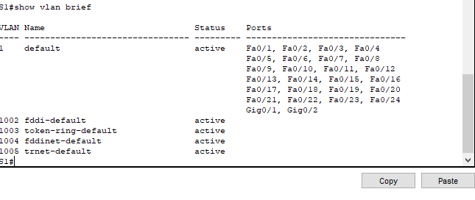

2. Notice that each PC can ping the other PC that shares the same subnet.
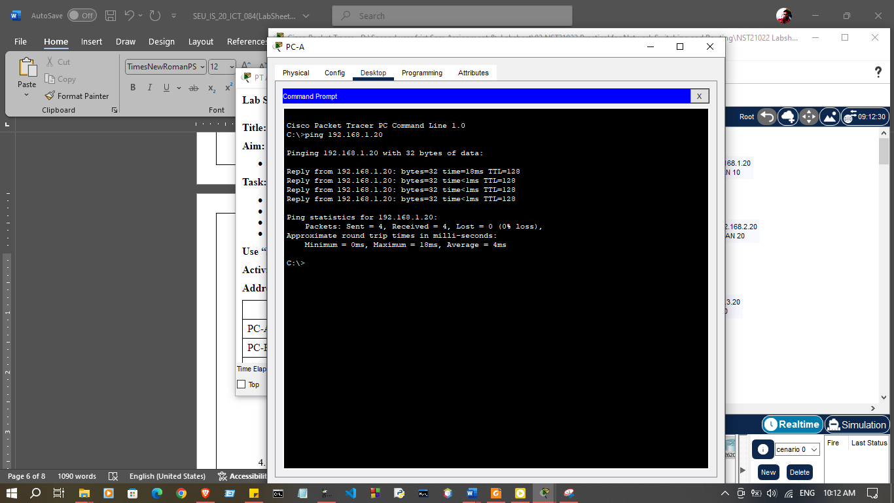
a) PC1 can ping PC4

b) PC2 can ping PC5

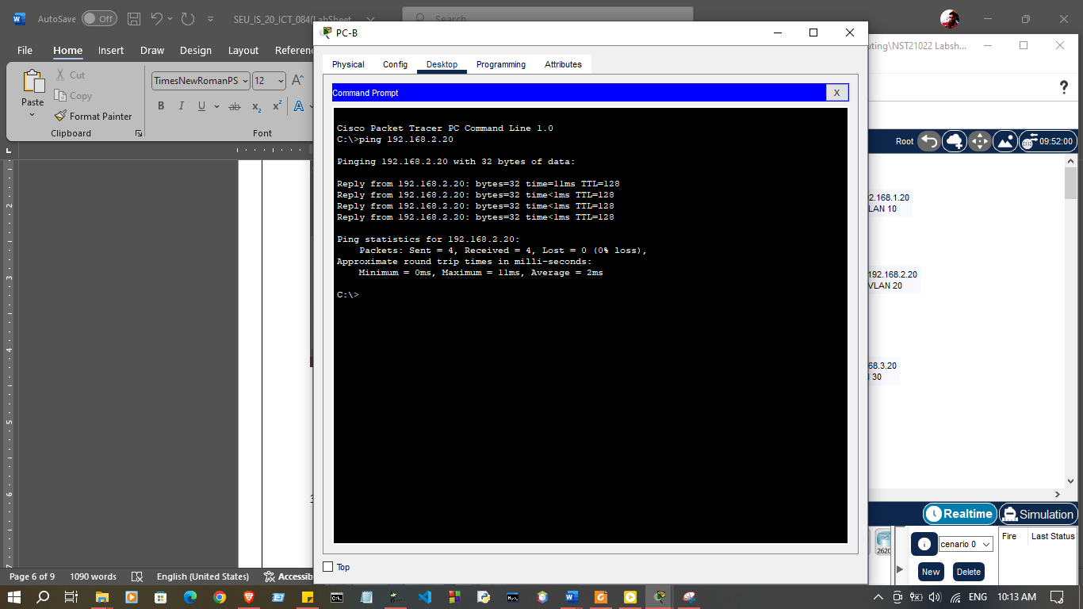

c) PC3 can ping PC6
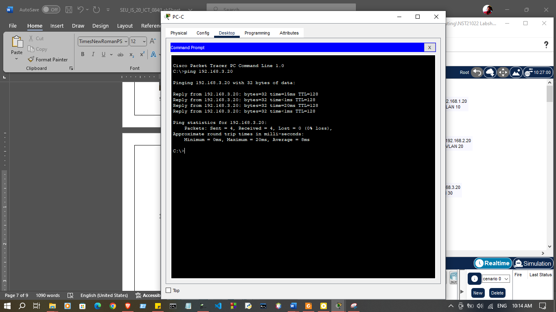

2.Create and name VLANs on S1

- Create the following VLANs. Names are case-sensitive and must match therequirement exactly.

- VLAN 10: Staff

S1#(config)# vlan 10
S1#(config-vlan)# name Staff

b) Create the remaining VLANs.
i. VLAN 20: Student
ii. VLAN 30: Guest
iii.VLAN 99: Management iv.
iv.VLAN 150: VOICE

S1#configure terminal
Enter configuration commands, one per line. End with CNTL/Z.
.
S1(config)#vlan 10
S1(config-vlan)#name Staff
S1(config-vlan)#vlan 20
S1(config-vlan)#name Student
S1(config-vlan)#vlan 30
S1(config-vlan)#name Guest
S1(config-vlan)#vlan 99
S1(config-vlan)#name Management
S1(config-vlan)#vlan 150
S1(config-vlan)#name VOICE
S1(config-vlan)#exit
S1(config)#exit
S1#show vlan brief
%SYS-5-CONFIG_I: Configured from console by console

VLAN Name Status Ports
---- -------------------------------- --------- -------------------------------
1 default active Fa0/1, Fa0/2, Fa0/3, Fa0/4
Fa0/5, Fa0/6, Fa0/7, Fa0/8
Fa0/9, Fa0/10, Fa0/11, Fa0/12
Fa0/13, Fa0/14, Fa0/15, Fa0/16
Fa0/17, Fa0/18, Fa0/19, Fa0/20
Fa0/21, Fa0/22, Fa0/23, Fa0/24
Gig0/1, Gig0/2
10 Staff active
20 Student active
30 Guest active
99 Management active
150 VOICE active
1002 fddi-default active
1003 token-ring-default active
1004 fddinet-default active
1005 trnet-default active
S1#

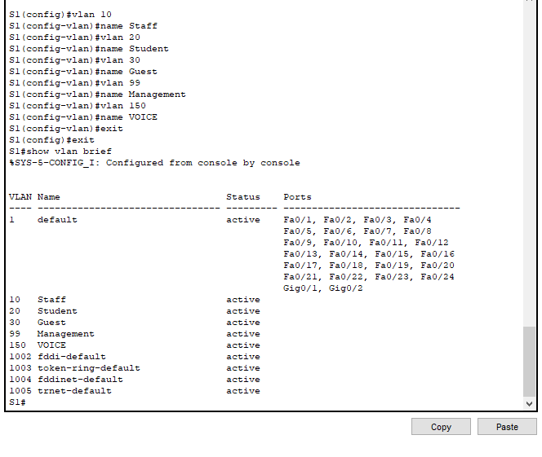

c)Verify the VLAN configuration using show vlan brief command

S1#show vlan brief
%SYS-5-CONFIG_I: Configured from console by console

VLAN Name Status Ports
---- -------------------------------- --------- -------------------------------
1 default active Fa0/1, Fa0/2, Fa0/3, Fa0/4
Fa0/5, Fa0/6, Fa0/7, Fa0/8
Fa0/9, Fa0/10, Fa0/11, Fa0/12
Fa0/13, Fa0/14, Fa0/15, Fa0/16
Fa0/17, Fa0/18, Fa0/19, Fa0/20
Fa0/21, Fa0/22, Fa0/23, Fa0/24
Gig0/1, Gig0/2
10 Staff active
20 Student active
30 Guest active
99 Management active
150 VOICE active
1002 fddi-default active
1003 token-ring-default active
1004 fddinet-default active
1005 trnet-default active
S1#
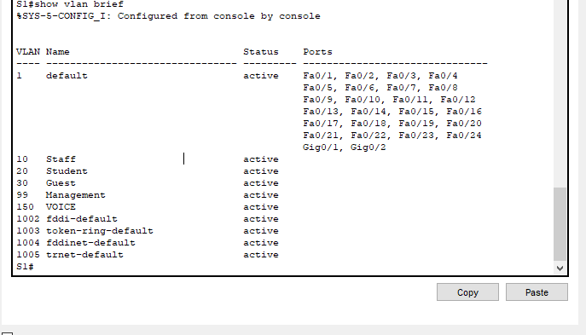

4. Create the VLANs on S2 and S3
a) Use the same commands from Number 3 to create and name the samem VLANs on S2 and S3.

S2>enable
S2#configure terminal
Enter configuration commands, one per line. End with CNTL/Z.
S2(config)#vlan 10
S2(config-vlan)#name Staff
S2(config-vlan)#vlan 20
S2(config-vlan)#name Student
S2(config-vlan)#vlan 30
S2(config-vlan)#name Guest
S2(config-vlan)#vlan 99
S2(config-vlan)#name Management
S2(config-vlan)#vlan 150
S2(config-vlan)#name VOICE
S2(config-vlan)#exit
S2(config)#exit
S2#

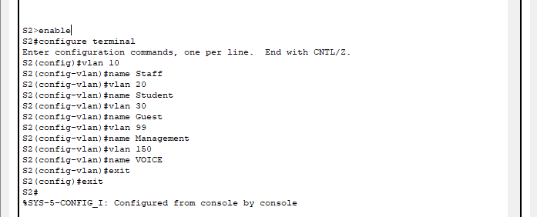

S3#configure terminal
Enter configuration commands, one per line. End with CNTL/Z.
S3(config)#vlan 10
S3(config-vlan)#name Staff
S3(config-vlan)#vlan 20
S3(config-vlan)#name Student
S3(config-vlan)#vlan 30
S3(config-vlan)#name Guest
S3(config-vlan)#vlan 99
S3(config-vlan)#name Management
S3(config-vlan)#vlan 150
S3(config-vlan)#name VOICE

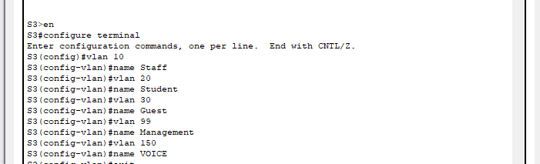

- Verify VLAN configuration

S2#
S2#
S2#show vlan brief

VLAN Name Status Ports
---- -------------------------------- --------- -------------------------------
1 default active Fa0/1, Fa0/2, Fa0/3, Fa0/4
Fa0/5, Fa0/6, Fa0/7, Fa0/8
Fa0/9, Fa0/10, Fa0/11, Fa0/12
Fa0/13, Fa0/14, Fa0/15, Fa0/16
Fa0/17, Fa0/18, Fa0/19, Fa0/20
Fa0/21, Fa0/22, Fa0/23, Fa0/24
Gig0/1, Gig0/2
10 Staff active
20 Student active
30 Guest active
99 Management active
150 VOICE active
1002 fddi-default active
1003 token-ring-default active
1004 fddinet-default active
1005 trnet-default active
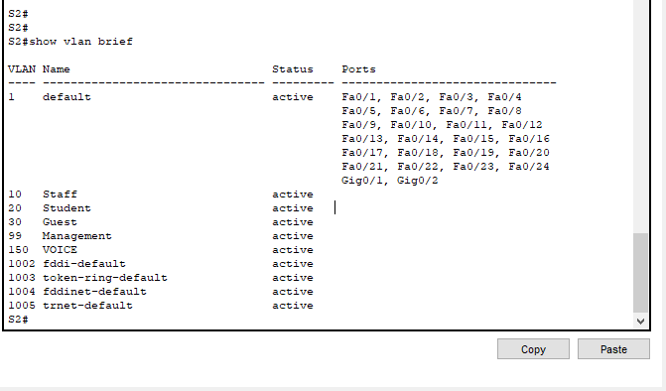
S2#

S3(config-vlan)#exit
S3(config)#exit
S3#show vlan brief
%SYS-5-CONFIG_I: Configured from console by console

VLAN Name Status Ports
---- -------------------------------- --------- -------------------------------
1 default active Fa0/1, Fa0/2, Fa0/3, Fa0/4
Fa0/5, Fa0/6, Fa0/7, Fa0/8
Fa0/9, Fa0/10, Fa0/11, Fa0/12
Fa0/13, Fa0/14, Fa0/15, Fa0/16
Fa0/17, Fa0/18, Fa0/19, Fa0/20
Fa0/21, Fa0/22, Fa0/23, Fa0/24
Gig0/1, Gig0/2
10 Staff active
20 Student active
30 Guest active
99 Management active
150 VOICE active
1002 fddi-default active
1003 token-ring-default active
1004 fddinet-default active
1005 trnet-default active
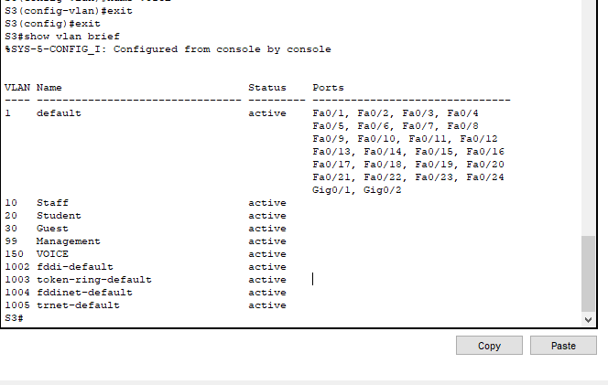
S3#

5. Assign VLANs to the active ports on S2.
a) Configure the interfaces as access ports and assign the VLANs as follows.
i. LAN 10: FastEthernet 0/1

S2(config)# interface f0/1
S2(config-if)# switchport mode access
S2(config-if)# switchport access vlan 10

b) Assign the remaining ports to the appropriate VLAN
i. VLAN 20: FastEthernet 0/11
ii. VLAN 30: FastEthernet 0/21
iii.VLAN 99: FastEthernet 0/24

S2#enable
S2#configure terminal
Enter configuration commands, one per line. End with CNTL/Z.
S2(config)#
S2(config)#interface fa0/1
S2(config-if)#switchport mode access
S2(config-if)#switchport access vlan 10
S2(config-if)#exit
S2(config)#
S2(config)#interface fa0/11
S2(config-if)#switchport mode access
S2(config-if)#switchport access vlan 20
S2(config-if)#exit
S2(config)#
S2(config)#
S2(config)#
S2(config)#interface fa0/21
S2(config-if)#switchport mode access
S2(config-if)#switchport access vlan 30
S2(config-if)#exit
S2(config)#
S2(config)#
S2(config)#interface fa0/24
S2(config-if)#switchport mode access
S2(config-if)#switchport access vlan 99
S2(config-if)#exit
S2(config)#
S2(config)#exit
S2#show vlan brief
%SYS-5-CONFIG_I: Configured from console by console

VLAN Name Status Ports
---- -------------------------------- --------- -------------------------------
1 default active Fa0/2, Fa0/3, Fa0/4, Fa0/5
Fa0/6, Fa0/7, Fa0/8, Fa0/9
Fa0/10, Fa0/12, Fa0/13, Fa0/14
Fa0/15, Fa0/16, Fa0/17, Fa0/18
Fa0/19, Fa0/20, Fa0/22, Fa0/23
Gig0/1, Gig0/2
10 Staff active Fa0/1
20 Student active Fa0/11
30 Guest active Fa0/21
99 Management active Fa0/24
150 VOICE active
1002 fddi-default active
1003 token-ring-default active
1004 fddinet-default active
1005 trnet-default active
S2#

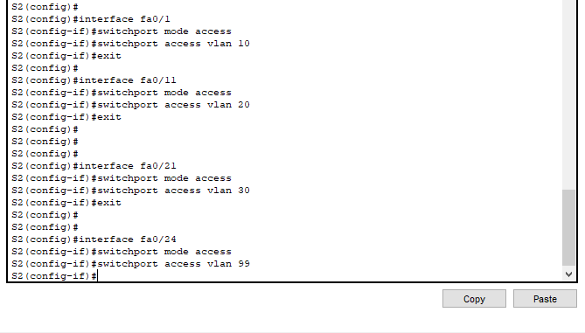

6. Assign VLANs to the active ports on S3.
a) S3 uses the same VLAN access port assignments as S2. Configure the interfaces as access ports and assign the VLANs as follows:

i. VLAN 10: FastEthernet 0/1
ii. VLAN 20: FastEthernet 0/11
iii.VLAN 30: FastEthernet 0/21

S3#configure terminal
Enter configuration commands, one per line. End with CNTL/Z.
S3(config)#interface fa0/1
S3(config-if)#switchport mode access
S3(config-if)#switchport access vlan 10
S3(config-if)#exit
S3(config)#
S3(config)#interface fa0/11
S3(config-if)#switchport mode access
S3(config-if)#switchport access vlan 20
S3(config-if)#exit
S3(config)#
S3(config)#
S3(config)#
S3(config)#interface fa0/21
S3(config-if)#switchport mode access
S3(config-if)#switchport access vlan 30
S3(config-if)#exit
S3(config)#
S3(config)#
S3(config)#interface fa0/24
S3(config-if)#switchport mode access
S3(config-if)#switchport access vlan 99
S3(config-if)#
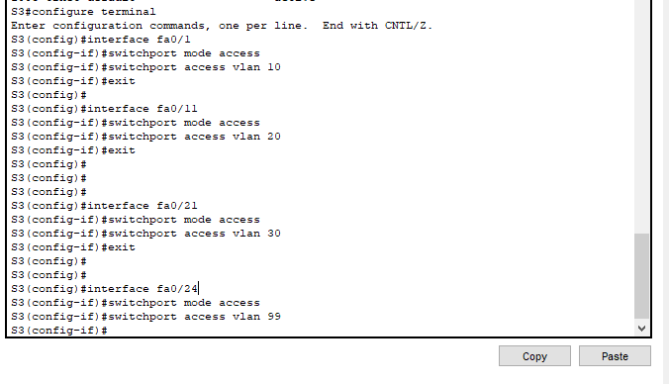

7. Assign the VOICE VLAN to FastEthernet 0/1 on S3.
a) Configure FastEthernet 0/11 for Cisco IP Phone and PC-D.
The S3 F0/1 interface must be configured to support user traffic to PC-D using VLAN 10 and voice traffic to the IP phone using VLAN 150. The interface must also enable QoS and trust the Class of Service (CoS) values assigned by the IP phone. IP voice traffic requires a minimum amount of throughput to support acceptable voice communication quality. This command helps the switchport to provide this minimum amount of throughput.

S3(config)# interface f0/1
S3(config-if)# mls qos trust cos
S3(config-if)# switchport voice vlan 150

S3(config-if)#interface f0/1
S3(config-if)#mls qos trust cos
S3(config-if)#switchport voice vlan 150
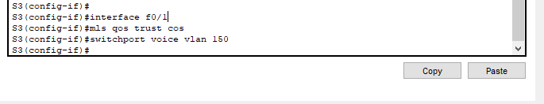
8. Verify loss of connectivity.
Previously, PCs that shared the same network could ping each other successfully. Study the output of from the following command on S2 and answer the following questions based on your knowledge of communication between VLANS. Pay close attention to the Gig0/1 port assignment.

S2# show vlan brief

S2#show vlan brief

VLAN Name Status Ports
---- -------------------------------- --------- -------------------------------
1 default active Fa0/2, Fa0/3, Fa0/4, Fa0/5
Fa0/6, Fa0/7, Fa0/8, Fa0/9
Fa0/10, Fa0/12, Fa0/13, Fa0/14
Fa0/15, Fa0/16, Fa0/17, Fa0/18
Fa0/19, Fa0/20, Fa0/22, Fa0/23
Gig0/1, Gig0/2
10 Staff active Fa0/1
20 Student active Fa0/11
30 Guest active Fa0/21
99 Management active Fa0/24
150 VOICE active
1002 fddi-default active
1003 token-ring-default active
1004 fddinet-default active
1005 trnet-default active

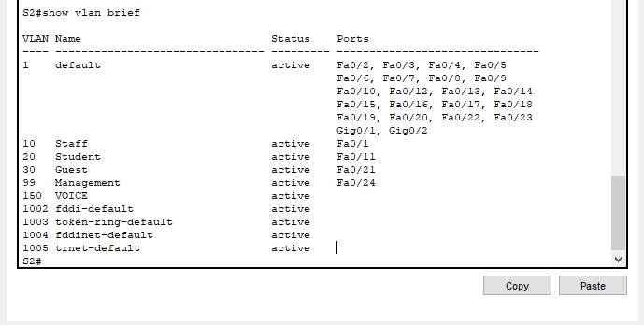

- Try pinging between PC-A and PC-D

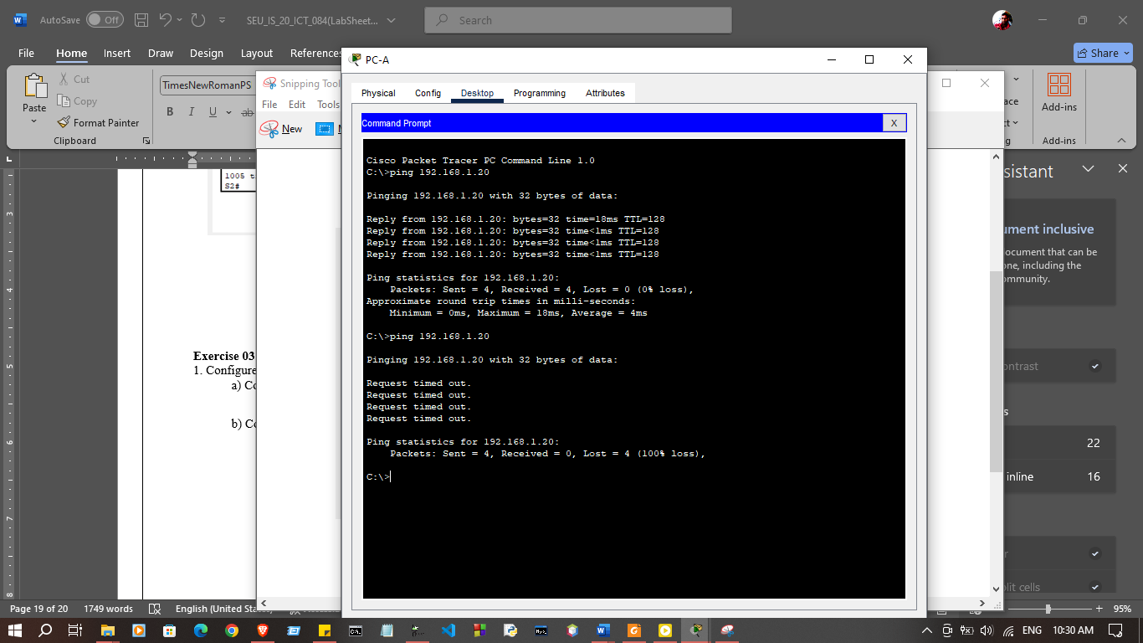

Exercise 03: Configure Trunks
1. Configure trunking on S1 and use VLAN 99 as the native VLAN.

a) Configure G0/1 and G0/2 interfaces on S1 for trunking.
S1(config)# interface range g0/1 - 2
S1(config-if)# switchport mode trunk

S1#configure terminal
Enter configuration commands, one per line. End with CNTL/Z.
S1(config)#interface range g0/1 - 2
S1(config-if-range)#switchport mode trunk

S1(config-if-range)#switchport trunk native vlan 99
%LINEPROTO-5-UPDOWN: Line protocol on Interface GigabitEthernet0/1, changed state to down

%LINEPROTO-5-UPDOWN: Line protocol on Interface GigabitEthernet0/1, changed state to up

%LINEPROTO-5-UPDOWN: Line protocol on Interface GigabitEthernet0/2, changed state to down

%LINEPROTO-5-UPDOWN: Line protocol on Interface GigabitEthernet0/2, changed state to up

S1(config-if-range)#

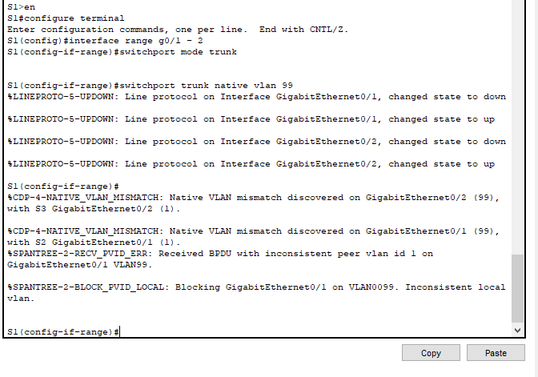

b) Configure VLAN 99 as the native VLAN for G0/1 and G0/2 interfaces on S1.

S1(config-if)# switchport trunk native vlan 99

The trunk port takes about a short time to become active due to Spanning Tree Protocol. After the ports become active, you will periodically receive the following syslog messages:

%CDP-4-NATIVE_VLAN_MISMATCH: Native VLAN mismatch discovered on GigabitEthernet0/2 (99), with S3 GigabitEthernet0/2 (1).
%CDP-4-NATIVE_VLAN_MISMATCH: Native VLAN mismatch discovered on GigabitEthernet0/1 (99), with S2 GigabitEthernet0/1 (1).

S1(config)#interface vlan 99
S1(config-if)#ip address 192.168.4.11 255.255.255.0
S1(config-if)#no shutdown
%LINK-5-CHANGED: Interface Vlan99, changed state to up

%LINEPROTO-5-UPDOWN: Line protocol on Interface Vlan99, changed state to up
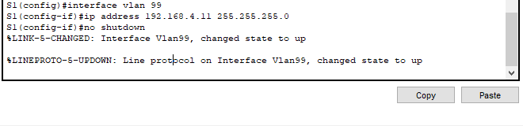

you configured VLAN 99 as the native VLAN on S1. S2 and S3 are using VLAN as the default native VLAN as indicated by the syslog message.

2. Correct the native VLAN mismatch on S2 and S3.
a) Configure VLAN 99 as the native VLAN for the appropriate interfaces on S2 and S3.

S2(config-if-range)#interface vlan 99
S2(config-if)#ip address 192.168.4.10 255.255.255.0
S2(config-if)#no shutdown
%LINK-5-CHANGED: Interface Vlan99, changed state to up

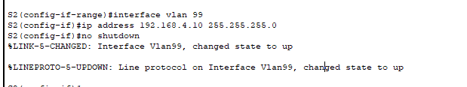

S3(config-if-range)#interface vlan 99
S3(config-if)#ip address 192.168.4.12 255.255.255.0
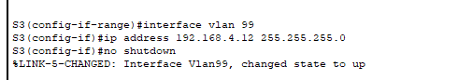
S3(config-if)#no shutdown

b)Issue show interface trunk command to verify the correct native VLAN configured.

S2>enable
S2#configure terminal
Enter configuration commands, one per line. End with CNTL/Z.
S2(config)#interface range g0/1 - 2
S2(config-if-range)#switchport mode trunk
S2(config-if-range)#switchport trunk native vlan 99
S2(config-if-range)#
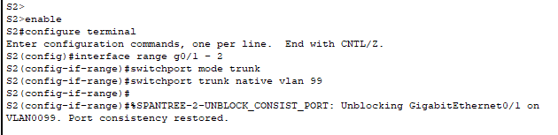

S3>enable
S3#configure terminal
Enter configuration commands, one per line. End with CNTL/Z.
S3(config)#interface range g0/1 - 2
S3(config-if-range)#switchport mode trunk
S3(config-if-range)#switchport trunk native vlan 99

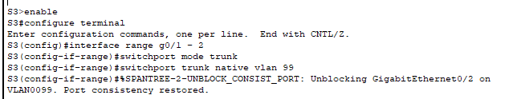

3. Verify configurations on S2 and S3.

- Issue the show interface interface switchport command to verify that the native VLAN is now 99.

S2>enable
S2#configure terminal
Enter configuration commands, one per line. End with CNTL/Z.
S2(config)#interface range g0/1 - 2
S2(config-if-range)#switchport mode trunk
S2(config-if-range)#switchport trunk native vlan 99
S2(config-if-range)#

S3>enable
S3#configure terminal
Enter configuration commands, one per line. End with CNTL/Z.
S3(config)#interface range g0/1 - 2
S3(config-if-range)#switchport mode trunk
S3(config-if-range)#switchport trunk native vlan 99

- Use the show vlan command to display information regarding configured VLANs.

S2#show vlan

VLAN Name Status Ports
---- -------------------------------- --------- -------------------------------
1 default active Fa0/2, Fa0/3, Fa0/4, Fa0/5
Fa0/6, Fa0/7, Fa0/8, Fa0/9
Fa0/10, Fa0/12, Fa0/13, Fa0/14
Fa0/15, Fa0/16, Fa0/17, Fa0/18
Fa0/19, Fa0/20, Fa0/22, Fa0/23
Gig0/2
10 Staff active Fa0/1
20 Student active Fa0/11
30 Guest active Fa0/21
99 Management active Fa0/24
150 VOICE active
1002 fddi-default active
1003 token-ring-default active
1004 fddinet-default active
1005 trnet-default active

VLAN Type SAID MTU Parent RingNo BridgeNo Stp BrdgMode Trans1 Trans2
---- ----- ---------- ----- ------ ------ -------- ---- -------- ------ ------
1 enet 100001 1500 - - - - - 0 0
10 enet 100010 1500 - - - - - 0 0
20 enet 100020 1500 - - - - - 0 0
30 enet 100030 1500 - - - - - 0 0
99 enet 100099 1500 - - - - - 0 0
150 enet 100150 1500 - - - - - 0 0
1002 fddi 101002 1500 - - - - - 0 0
1003 tr 101003 1500 - - - - - 0 0
1004 fdnet 101004 1500 - - - ieee - 0 0
1005 trnet 101005 1500 - - - ibm - 0 0

VLAN Type SAID MTU Parent RingNo BridgeNo Stp BrdgMode Trans1 Trans2
---- ----- ---------- ----- ------ ------ -------- ---- -------- ------ ------

Remote SPAN VLANs
------------------------------------------------------------------------------

Primary Secondary Type Ports
------- --------- ----------------- ------------------------------------------
S2#

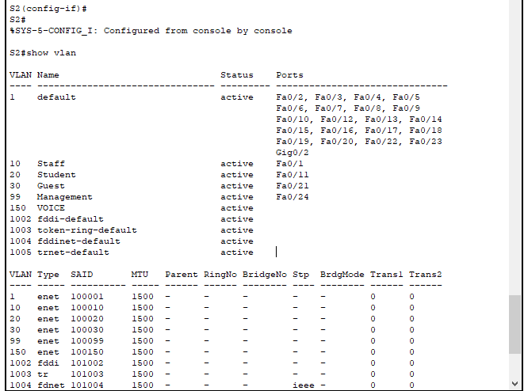
S3#show vlan

VLAN Name Status Ports
---- -------------------------------- --------- -------------------------------
1 default active Fa0/2, Fa0/3, Fa0/4, Fa0/5
Fa0/6, Fa0/7, Fa0/8, Fa0/9
Fa0/10, Fa0/12, Fa0/13, Fa0/14
Fa0/15, Fa0/16, Fa0/17, Fa0/18
Fa0/19, Fa0/20, Fa0/22, Fa0/23
Gig0/1
10 Staff active Fa0/1
20 Student active Fa0/11
30 Guest active Fa0/21
99 Management active Fa0/24
150 VOICE active Fa0/1
1002 fddi-default active
1003 token-ring-default active
1004 fddinet-default active
1005 trnet-default active

VLAN Type SAID MTU Parent RingNo BridgeNo Stp BrdgMode Trans1 Trans2
---- ----- ---------- ----- ------ ------ -------- ---- -------- ------ ------
1 enet 100001 1500 - - - - - 0 0
10 enet 100010 1500 - - - - - 0 0
20 enet 100020 1500 - - - - - 0 0
30 enet 100030 1500 - - - - - 0 0
99 enet 100099 1500 - - - - - 0 0
150 enet 100150 1500 - - - - - 0 0
1002 fddi 101002 1500 - - - - - 0 0
1003 tr 101003 1500 - - - - - 0 0
1004 fdnet 101004 1500 - - - ieee - 0 0
1005 trnet 101005 1500 - - - ibm - 0 0

VLAN Type SAID MTU Parent RingNo BridgeNo Stp BrdgMode Trans1 Trans2
---- ----- ---------- ----- ------ ------ -------- ---- -------- ------ ------

Remote SPAN VLANs
------------------------------------------------------------------------------
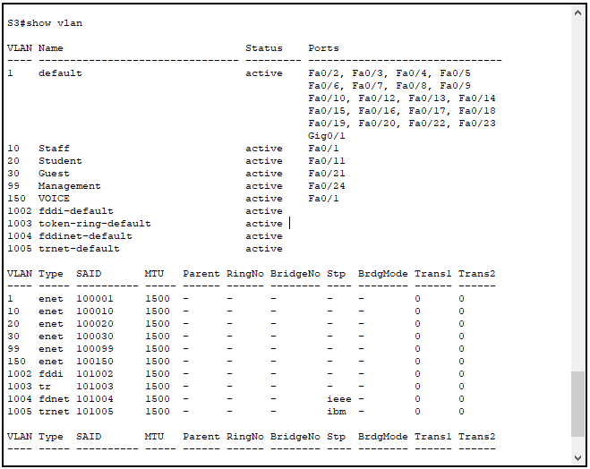
Primary Secondary Type Ports
------- --------- ----------------- ------------------------------------------
Exercise 04: Configure Secure Password and SSH

01.Configure IP address for Management VLAN according to Addressing Table and enable interface status

S1>enable
S1#config t
Enter configuration commands, one per line. End with CNTL/Z.
S1(config)#
S1(config)#interface vlan 99
S1(config-if)#ip address 192.168.4.12 255.255.255.0
S1(config-if)#no shutdown
S1(config-if)#

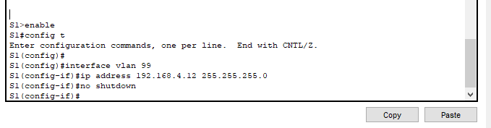

S2#enable
S2#config t
Enter configuration commands, one per line. End with CNTL/Z.
S2(config)#
S2(config)#interface vlan 99
S2(config-if)#ip address 192.168.4.12 255.255.255.0
S2(config-if)#no shutdown
S2(config-if)#

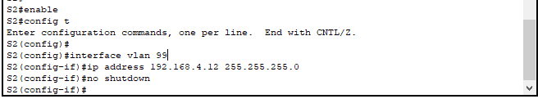

S3#enable
S3#config t
Enter configuration commands, one per line. End with CNTL/Z.
S3(config)#
S3(config)#interface vlan 99
S3(config-if)#ip address 192.168.4.12 255.255.255.0
S3(config-if)#no shutdown
S3(config-if)#

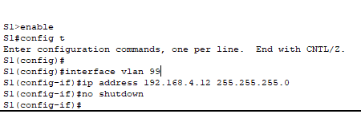

2. Create a user of your choosing with a strong encrypted password.

S2(config)# username root secret cisco

S1(config-if)#username root secret cisco
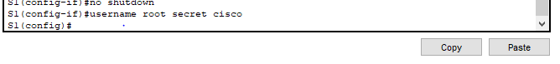

S2(config-if)#username root secret cisco

S3(config)#username root secret cisco

3. Generate 1024-bit RSA keys.

Note: In Packet Tracer, enter the crypto key generate rsa command and press Enter to continue.

S2(config)# crypto key generate rsa

The name for the keys will be: RTA.CCNA.com. Choose the size of the key modulus in the range of 360 to 2048 for your General Purpose Keys. Choosing a key modulus greater than 512 may take a few minutes.

How many bits in the modulus [512]: 1024
S1(config-if)#username root secret cisco
S1(config)#crypto key generate rsa
The name for the keys will be: S1.ccna.com
Choose the size of the key modulus in the range of 360 to 4096 for your
General Purpose Keys. Choosing a key modulus greater than 512 may take
a few minutes.

How many bits in the modulus [512]: 1024
% Generating 1024 bit RSA keys, keys will be non-exportable...[OK]

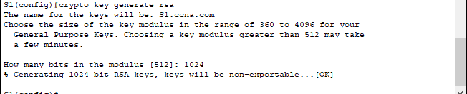
S1(config)#

S2(config)#crypto key generate rsa
The name for the keys will be: S2.ccna.com
Choose the size of the key modulus in the range of 360 to 4096 for your
General Purpose Keys. Choosing a key modulus greater than 512 may take
a few minutes.

How many bits in the modulus [512]: 1024
% Generating 1024 bit RSA keys, keys will be non-exportable...[OK]

S2(config)#
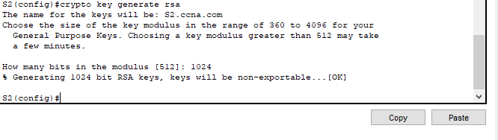
S3(config)#crypto key generate rsa
The name for the keys will be: S3.ccna.com
Choose the size of the key modulus in the range of 360 to 4096 for your
General Purpose Keys. Choosing a key modulus greater than 512 may take
a few minutes.

How many bits in the modulus [512]: 1024
% Generating 1024 bit RSA keys, keys will be non-exportable...[OK]

S3(config)#
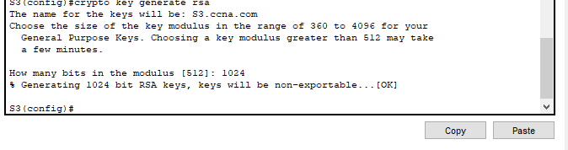

4. Configure all VTY lines for SSH access and use the local user profiles for authentication.

S2(config)# line vty 0 4
S2(config-line)# transport input ssh
S2(config-line)# login local

S1(config)#line vty 0
S1(config-line)#transport input ssh
S1(config-line)#login local
S1(config-line)#exec-timeout 6
S1(config-line)#
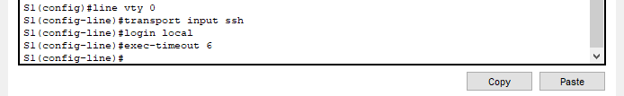

S2(config)#line vty 0
*Mar 1 2:25:41.393: %SSH-5-ENABLED: SSH 1.99 has been enabled
S2(config-line)#transport input ssh
S2(config-line)#login local
S2(config-line)#exec-timeout 6
S2(config-line)#

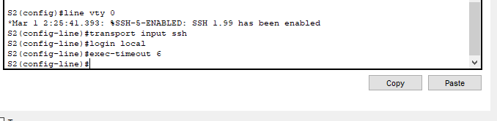

S3(config)#
S3(config)#line vty 0
S3(config-line)#transport input ssh
S3(config-line)#login local
S3(config-line)#exec-timeout 6
S3(config-line)#line vty 15
S3(config-line)#transport input ssh
S3(config-line)#login local
S3(config-line)#exec-timeout 6
S3(config-line)#
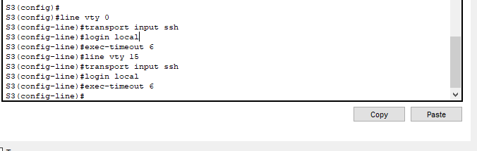

5. Set the EXEC mode timeout to 6 minutes on the VTY lines.

S2(config-line)# exec-timeout 6

S1(config)#
S1(config)#
S1(config)#line vty 0
S1(config-line)#transport input ssh
S1(config-line)#login local
S1(config-line)#exec-timeout 6
S1(config-line)#line vty 15
S1(config-line)#transport input ssh
S1(config-line)#login local
S1(config-line)#exec-timeout 6
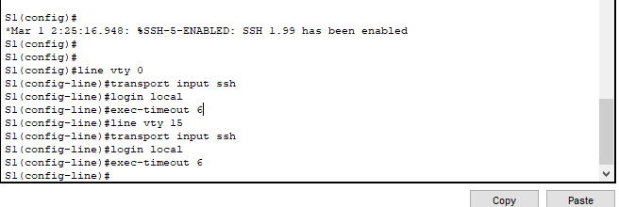
S1(config-line)#

S2(config)#line vty 0
*Mar 1 2:25:41.393: %SSH-5-ENABLED: SSH 1.99 has been enabled
S2(config-line)#transport input ssh
S2(config-line)#login local
S2(config-line)#exec-timeout 6
S2(config-line)#line vty 15
S2(config-line)#transport input ssh
S2(config-line)#login local
S2(config-line)#exec-timeout 6
S2(config-line)#
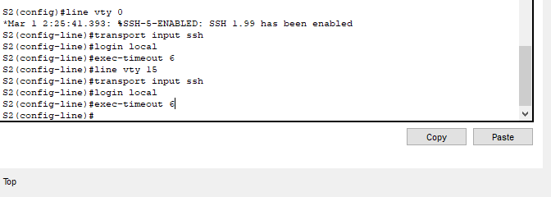

S3(config)#
S3(config)#line vty 0
S3(config-line)#transport input ssh
S3(config-line)#login local
S3(config-line)#exec-timeout 6
S3(config-line)#line vty 15
S3(config-line)#transport input ssh
S3(config-line)#login local
S3(config-line)#exec-timeout 6
S3(config-line)#

6. Save the configuration to NVRAM.

S1#copy running-config startup-config
Destination filename [startup-config]?
Building configuration...
[OK]
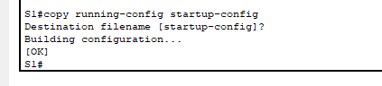
S1#

S2#copy running-config startup-config
Destination filename [startup-config]?
Building configuration...
[OK]
S2#
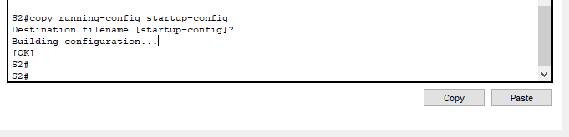

S3#copy running-config startup-config
Destination filename [startup-config]?
Building configuration...
[OK]
S3#

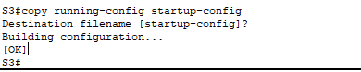

7. Access the command prompt on the desktop of Management PC to establish an SSH connection to S2. Open a command prompt

C:\> ssh /? Packet Tracer PC SSH
Usage: SSH -l username target C:\>
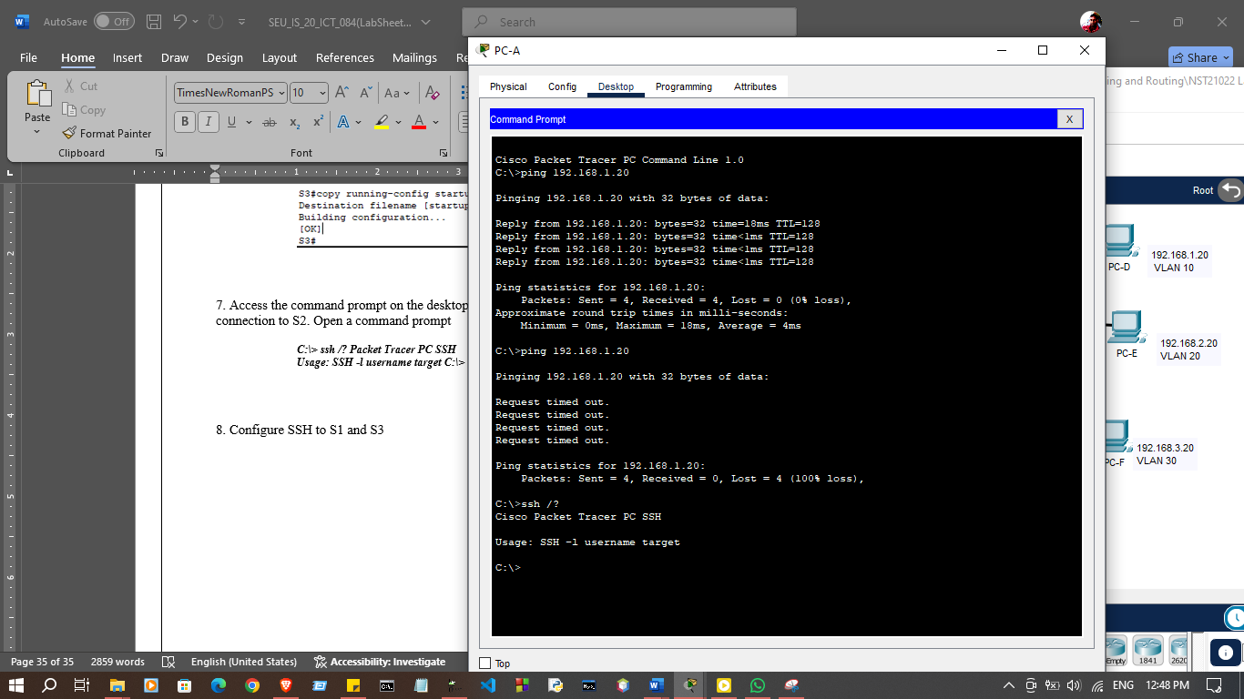

8. Configure SSH to S1 and S3
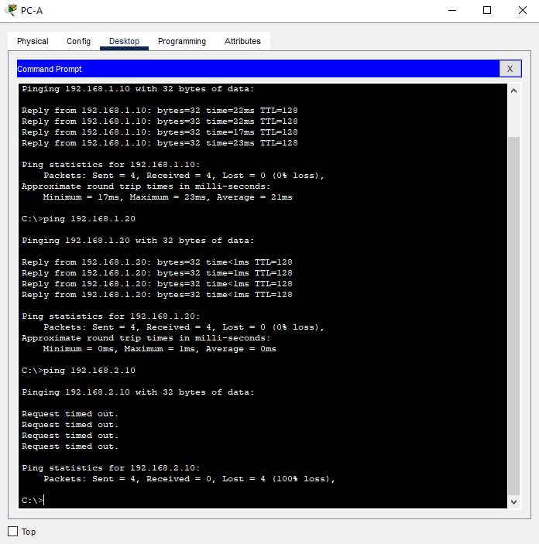

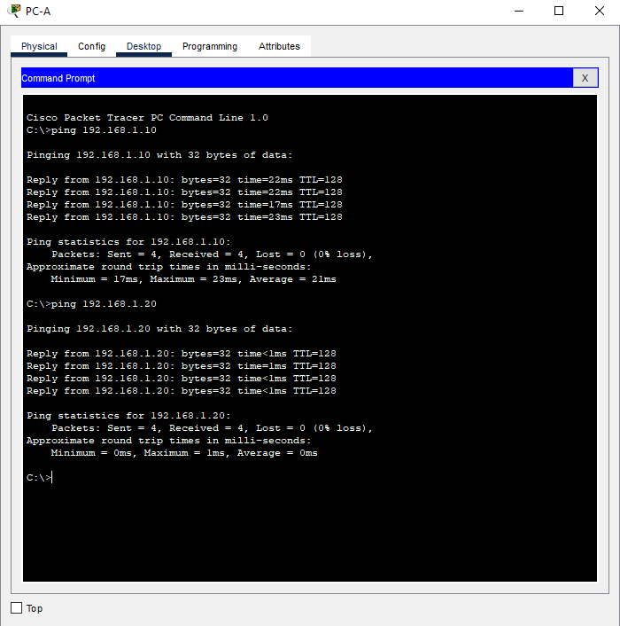

Discussion
- In this lab practical session, I focused on gaining hands-on experience with Virtual Local Area Networks (VLANs) and Secure Shell (SSH) for secure remote management of network devices. The first task involved setting up a basic configuration of the network devices, ensuring they were ready for more advanced setups. I then moved on to configuring VLANs, which allowed me to segment the network into distinct broadcast domains, improving both performance and security. Following that, I configured trunking between switches to enable the transfer of multiple VLANs over a single link, ensuring seamless communication across different segments. Finally, I implemented secure passwords and SSH for remote access, which provided a crucial layer of security, safeguarding my network management from unauthorized access. This session enhanced my understanding of VLANs and SSH while reinforcing best practices in network configuration and security

